ECU Simulator User Manual

Shenzhen CASTEL Wireless Telecommunications, Co., Ltd

Version：V1.0.0

2012．5

1 Products Introduction
ECU simulator is the product which used in the development process of debugging and testing with ECU communication products. A wide range and different models of automotive ECU products in the OBD development and testing process, and some ECU is observed and difficult to find in the real vehicle ECU test. Meanwhile, the connection between the platform and the real vehicle ECU test is complex, and it is not good for DTC replay and the development of desktop and the future product testing work. Use ECU simulation to simulate a variety of ECU communication test, the software configuration parameters are flexible, convenient, simple and reliable to connect wire. It can meet almost all models of the market for ECU communication through simulation parameter adjustment, which is greatly facilitates the ECU development and testing of communications products.

2. Use Instruction
Interface Introduction
ECU simulator is composed of PC end simulation software and a communication protocol converter control board.
Communication protocol on-board on the market uses a variety of ECU communication protocol hardware circuit. It can switch communication protocols, set parameters flexibly through the PC software. All operations of the simulator can be achieved through the software interface after the connection to the hardware. The software main operation interface as follows:

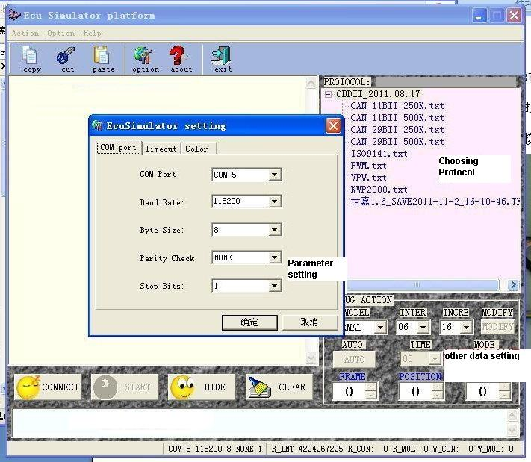

Connection Introduction
ECU virtual simulator connection interface has12 power lead and the PC serial port, and standard OBD diagnostic connector.
12V power line connect to the 12V power supply output, the red line is positive, the black line is negative.
PC serial port connects to 232 standard serial port of the PC, and without serial port computer can use USB virtual serial line to achieve normal communication.
OBD diagnosis head is compatible with the car standard OBD diagnostic pin, and it is connect to OBD during test.

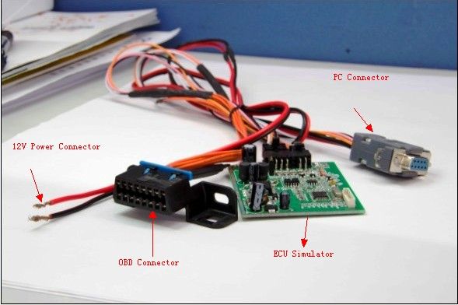

Operation Introduction
- Configuration port
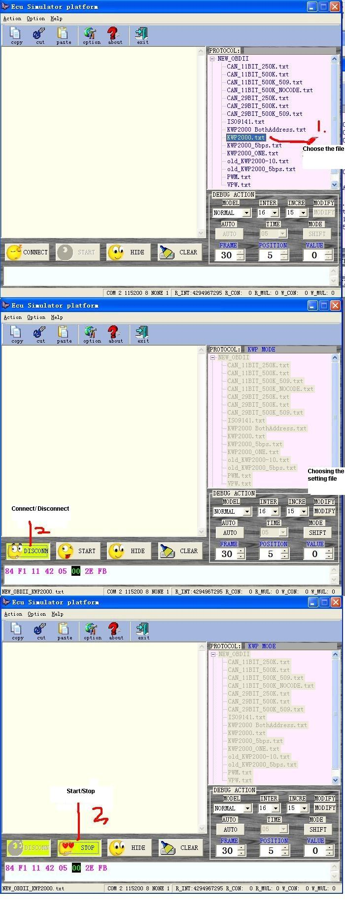
- Select configuration file
- Mail interface buttons instructions
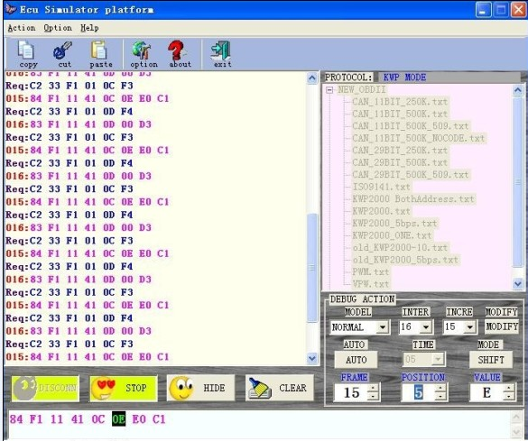

Configuration file instructions
Each protocol corresponds to a protocol text file that is fixed format, save the configuration parameters of each protocol, a brief introduction to the text of a protocol as an example as follows:

KWP2000.txt file，these fields mean:
CSMod=00 ; 00: ADD 01: 03 02: XOR 03: ADD Them Reverse 04: CRC default: ADD 10: no CS
CSMod check type:
0 is check summation, as the follow frame Req:C1 33 F1 81 66 ，66is the check value=C1+33+F1+81. Specific frame structure can refer to OBD protocol.
1 is ADD used in KWP/ISO9141 protocol
4 CRC check used in PWM/VPW protocol
Default: check summation
10：No check used in CAN protocol
Not used in the others.

EnterMod=00 RxB2B=12, 00 RxF2F=30, 00 TxB2B=0A, 00 TxF2F=30, 00; 00: Kwp 01:5bps 02 5bpsII 03: VPW 04: PWM 05: CAN

EnterMod communication type: a total of 5kinds，00:Kwp 01:5bps 02 5bpsII 03:VPW 04:PWM 05:CAN；
RxB2B: receive data frame and frame and the interval time is
00ms~0x12ms
RxF2F: receive data frame and frame and the interval time is
00ms~0x30ms
TxB2B: receive data frame and frame and the interval time is
00ms~0x0ams
TxF2F: receive data frame and frame and the interval time is
00ms~0x30ms

BaudRate=10416, NONE, 1, the Baud Rate value here!

BaudRate communication baud rate，10416BPS

; enter the line start with“;”byte means comment line
Req: C1 33 F1 81 66 OBDSMART The requested data frame that means this frame representation enter into OBD system
Ans: 83 F1 11 C1 EF 8F C4 simulators the reply data frame that mean this frame representation enter into OBD successfully.

All of Req: all start lines are the data frame which is sent by OBDSMART device,
Ans: all start lines are the data frame which is replied by simulator.

; Info
Req:C2 33 F1 01 00 E7 OBDSMART The requested data frame that means this frame representation request read the vehicle first group PID

Ans: 86 F1 11 41 00 BE 3E B8 11 8E BE 3E B8 11 Can determine the PID of the ECU the first group which is supported and which is not. The detail can refer to OBD protocol.

Req: C2 33 F1 01 01 E8 OBDSMART The requested data frame that means this frame representation request to read the vehicle ready information.

Ans: 86 F1 11 41 01 81 07 E1 E0 13 81 07 E1 E0 is the ready information, detail refer to OBD protocol.

; Store codes
Req: C1 33 F1 03 E8 OBDSMART The requested data frame that means this frame representation request read the STORE DTC.

Ans: 1N 87 F1 11 43 01 22 01 23 02 23 EF the following three - line is the data frame which is replied by simulator, a total of three frames. There is “1N “before the first two frames mean it followed by other frames, and it means end until the last frame without1N.

Ans: 1N 87 F1 11 43 01 13 01 83 04 62 EF
Ans: 87 F1 11 43 04 47 21 22 21 27 EF

The 3 frames means the DTC information is 0122,0123,0223,0113 , 0183, 0462,0447,2122,2127,a total of 9.

3. Notes
1 The tested OBD device power is supplied by the simulator, please make sure the simulator connect to the power and voltage correctly before power-up the connect the device.
2 Simulator software communication protocol text support standard OBD protocol, the non-standard OBD type virtual communication, various models vehicles need to be modified, add protocol and modify parameter. Virtual fixture cannot completely simulate vehicle ECU, it is necessary to test real-time vehicle communication.
3. Frequent change the protocol, disconnect and connect the operation or close the software during normal communication may cause the interrupt of simulator hardware, leading the next cannot connect. Please re-power the simulator after power interrupt.
4. Use virtual USB serial port to communicate, it is not unplugging the USB to serial cable before shut-off the communication connect un-normally. Or else, it will cause simulator software error due to the WINDOWS system hardware error.

